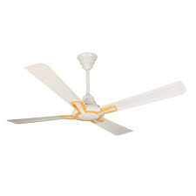

DW 7500 G

* Deep Water Fall Technology
* Shower Rinse
* Glass Lid
* 2 Year Warranty

**Rs 27,500**